|  |
| --- |
| **Front End Engineering-II**    Project Report  Semester-IV (Batch-2022)    Title of the Project: -  L’Gran  Food of your choice    **Supervised By: Submitted By:**  Raveesh Samkaria Shivansh Sharma  Roll Number: -2210990833  Group - 13    **Department of Computer Science and Engineering**  **Chitkara University Institute of Engineering & Technology,**  **Chitkara University, Punjab** |

# Abstract

L'Gran is a sophisticated online booking restaurant offering a seamless and intuitive platform for diners to reserve tables and indulge in culinary excellence. With a focus on delivering exceptional dining experiences, L'Gran combines the convenience of online booking with the artistry of fine cuisine. Through a curated selection of dishes inspired by global flavours and prepared by talented chefs, L'Gran promises to tantalize the senses and elevate every meal into a memorable occasion. Whether it's an intimate dinner for two or a festive gathering with friends, L'Gran invites diners to embark on a culinary journey filled with flavour, innovation, and unparalleled hospitality.

Table of Contents

|  |  |  |
| --- | --- | --- |
| **Sr.no** | **Section** | **Page No** |
| **1.** | Introduction | 3 |
| **2.** | Problem Statement | 4 |
| **3.** | Technical Details | 5 |
| **4.** | File Structure | 6 |
| **5.** | Result | 7 |
| **6.** | References | 32 |

## Introduction

Welcome to L’Gran Your Passport to Culinary Excellence. where gastronomic adventures and culinary excellence converge in the heart of the online dining landscape. Nestled in the digital realm, L'Gran is not just a restaurant; it's an experience, a journey through flavours, and a celebration of fine dining.

L'Gran is your gateway to a world of culinary delights, offering a seamless online booking platform that brings together food aficionados and discerning diners with a penchant for exquisite tastes. Whether you're a connoisseur seeking the perfect ambiance for a romantic dinner, a group of friends looking to savour the latest culinary trends, or a family in search of a memorable dining experience, L'Gran caters to all palates and preferences.

At L'Gran, we believe that every meal should be an event to remember. Our curated selection of dishes showcases the artistry and passion of our talented chefs, who draw inspiration from global cuisines while infusing each creation with their own unique flair. From mouthwatering appetizers to decadent desserts, every bite at L'Gran is a symphony of flavours, textures, and aromas that tantalize the senses and leave a lasting impression.

But L'Gran is more than just a restaurant; it's a destination where hospitality meets innovation. Our intuitive online booking system makes reserving a table effortless, allowing you to plan your dining experience with ease and convenience. Whether you prefer an intimate dinner for two, a lively gathering with friends, or a special occasion worth celebrating, L'Gran ensures that every moment spent in our virtual dining realm is nothing short of extraordinary.

Join us at L'Gran and embark on a culinary journey like no other. Whether you're a seasoned foodie or someone discovering the joys of fine dining for the first time, L'Gran invites you to indulge your senses, elevate your palate, and make memories that will last a lifetime.

Top of Form

## Problem Statement

In today's fast-paced world, diners are increasingly turning to online platforms to streamline their restaurant reservations and dining experiences. However, amidst a sea of options, there remains a need for a sophisticated online booking restaurant that seamlessly combines convenience with culinary excellence. L'Gran aims to address this need by providing a solution for diners who seek a refined dining experience but may struggle to find a platform that offers both intuitive online booking functionality and exceptional gastronomic offerings.

The current landscape of online restaurant booking platforms often lacks the finesse and attention to detail required to truly elevate the dining experience. Users may encounter difficulties in navigating through cumbersome interfaces, limited selection of restaurants, or inconsistent quality of service. Moreover, traditional booking systems may not fully leverage the potential of digital technology to enhance the overall dining journey, leaving diners feeling unsatisfied and disengaged.

For L'Gran, the challenge lies in creating a seamless and intuitive online booking platform that not only simplifies the reservation process but also delivers on the promise of culinary excellence. This involves addressing key pain points such as accessibility, variety, reliability, and user experience. By focusing on these aspects, L'Gran aims to differentiate itself in the market and emerge as the go-to destination for discerning diners seeking a memorable and hassle-free dining experience.

## Technical Details

The front-end website for the design agency was constructed with a minimalist approach, employing only essential technologies to ensure a streamlined user experience. Here are the primary technical details of the project:

* **HTML Structure:** The website's structure was crafted using semantic HTML markup to enhance accessibility and clarity. Each page was organized with appropriate tags to facilitate straightforward navigation and readability.
* **CSS Styling:** Cascading Style Sheets (CSS) were utilized for styling the website's layout, typography, and color schemes. Custom CSS rules were applied to maintain a consistent visual design across the site while optimizing load times and code simplicity.
* **Responsive Design:** Responsive design principles were implemented to ensure the website's compatibility with various devices and screen sizes. Media queries and flexible layouts were employed to adapt the content and design elements responsively without reliance on frameworks.

## File Structure: -

* **index.html:** This file serves as the main entry point for the website. It contains the HTML markup defining the structure and content of the web pages. Within this file, sections such as the header, navigation bar, main content area, footer, and any additional elements are defined.
* **style.css:** The CSS file contains the styling rules that dictate the visual presentation of the website. This includes defining colours, fonts, layout properties, and any other stylistic elements. Selectors within this file target specific HTML elements or classes to apply the desired styles.
* **image folder:** This folder contains all the images used throughout the website. Images may include logos, background images, or any other visual assets required to enhance the design and content presentation. Proper organization within this folder helps maintain the clarity and accessibility of image resources.

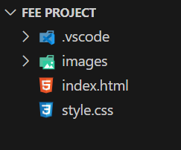

## Result

Webpage Screenshots: -

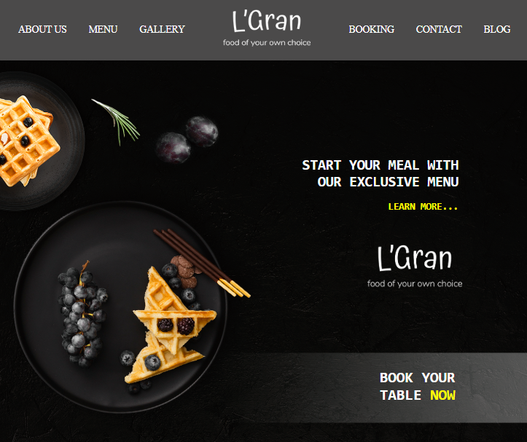

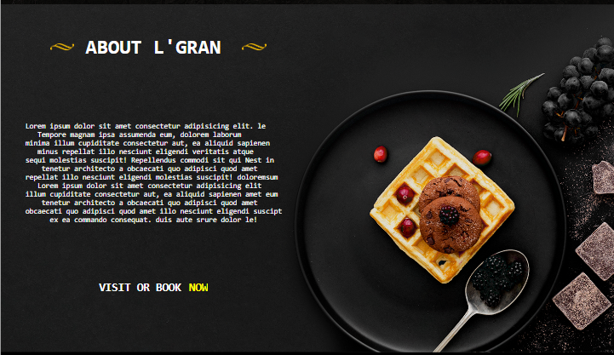

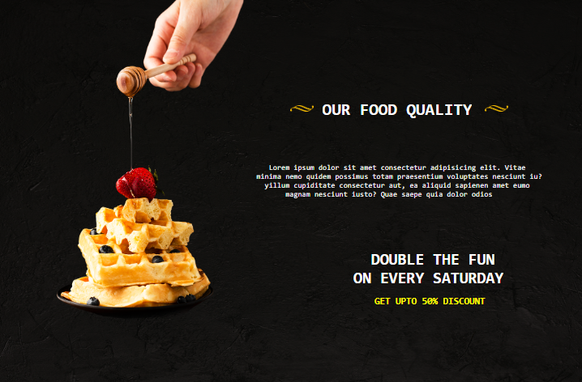

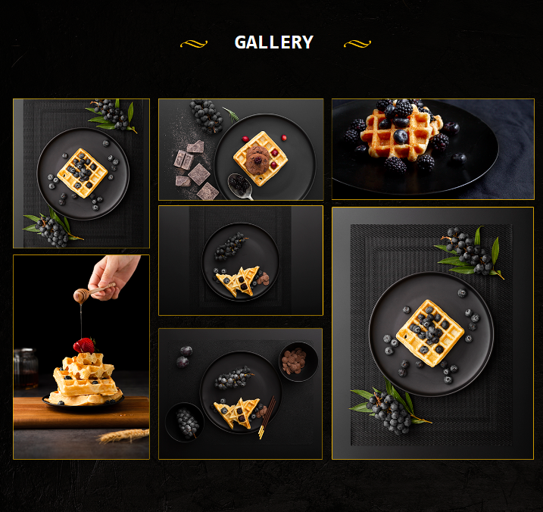 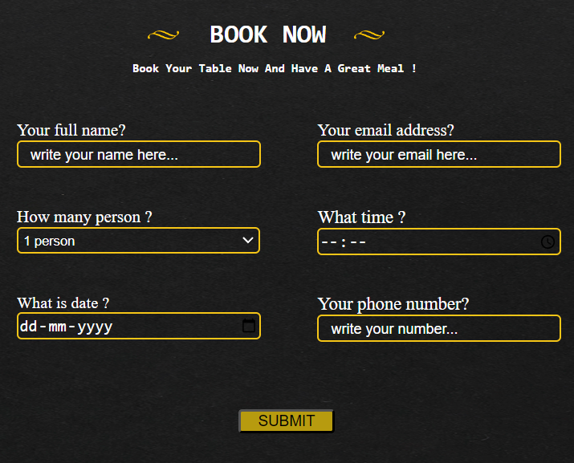 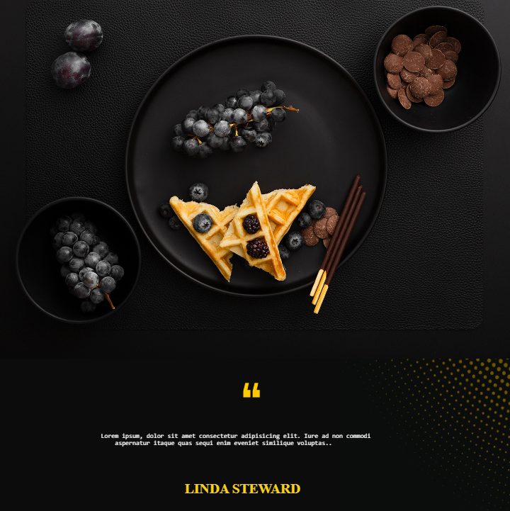

**HTML CODE:-**

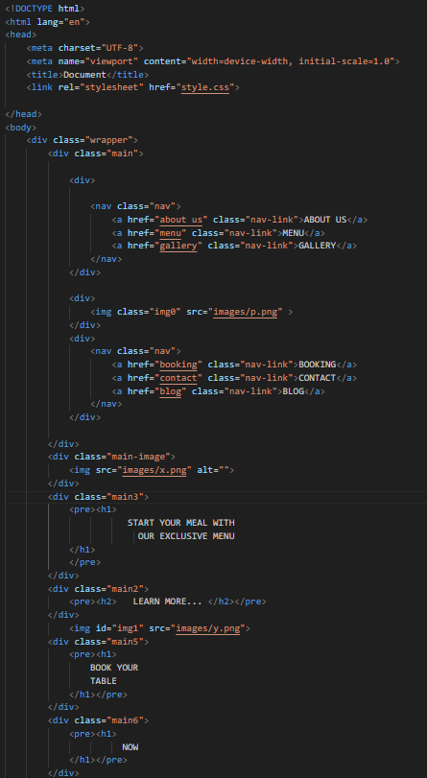

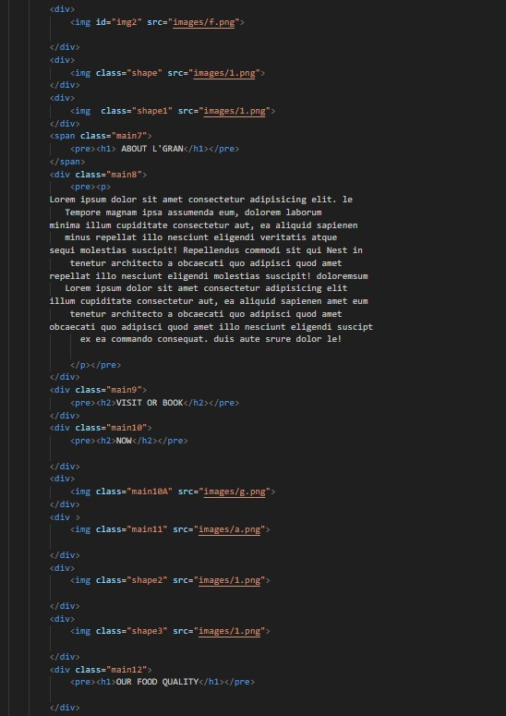

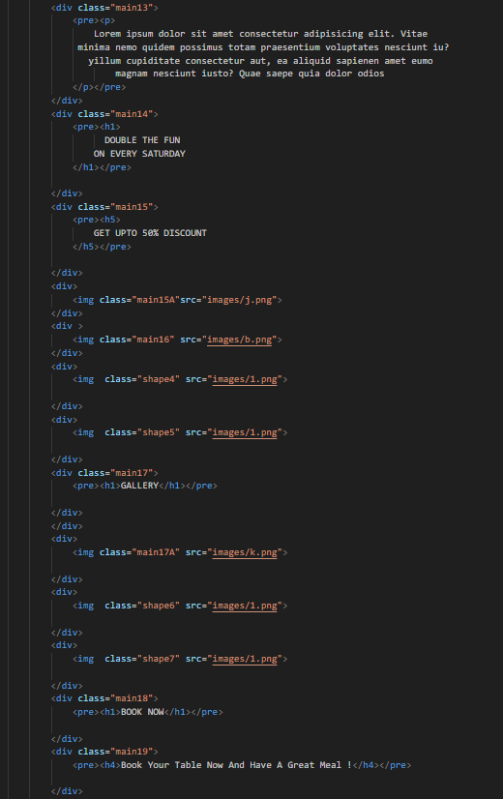 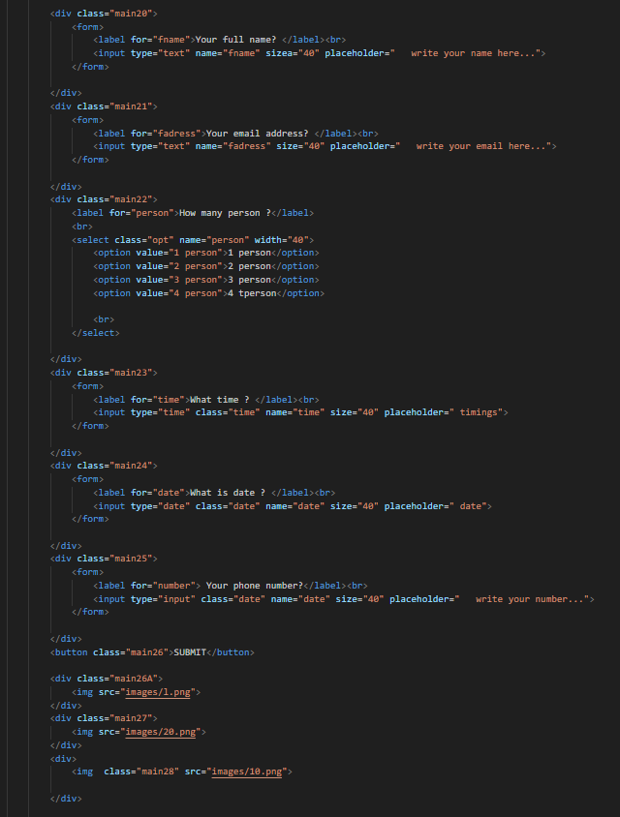 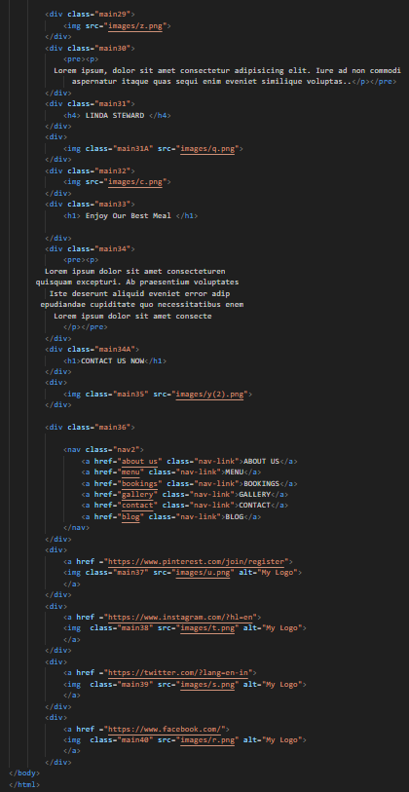

**CSS-CODE:-**

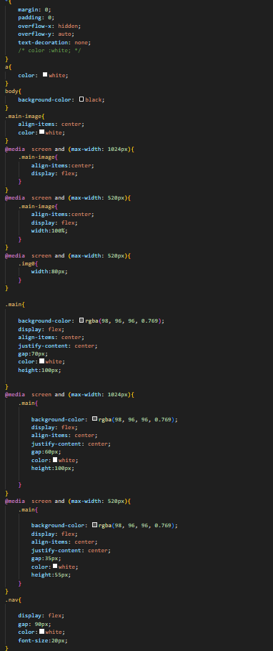

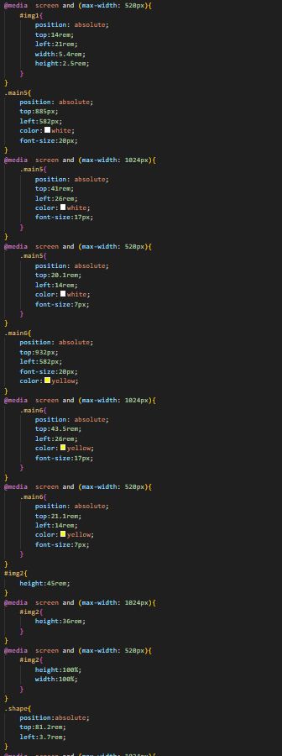 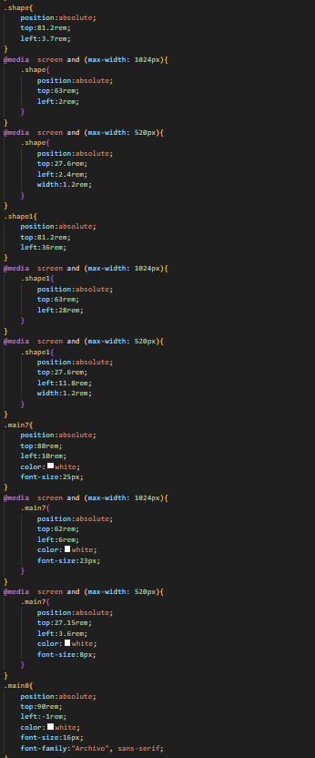 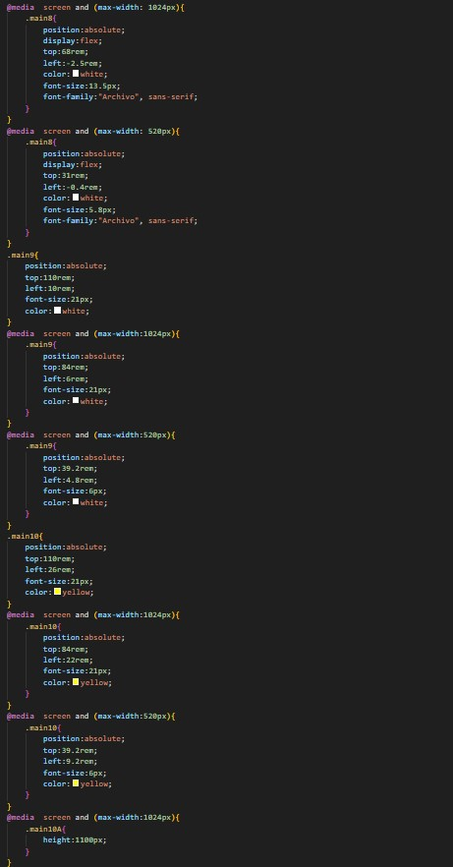

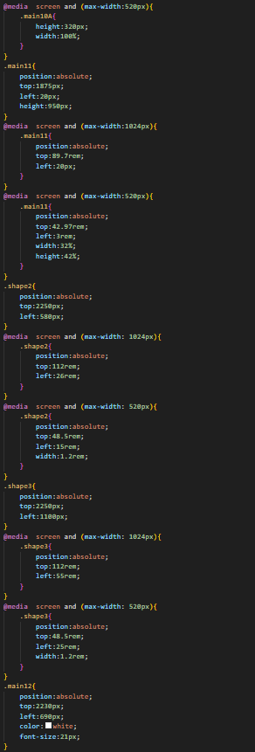

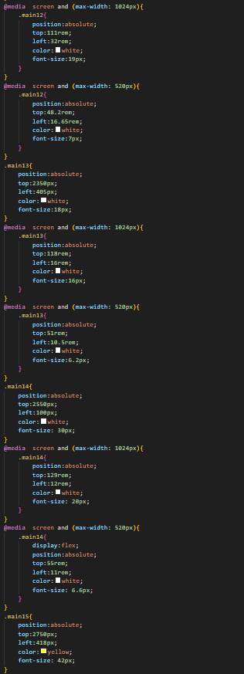

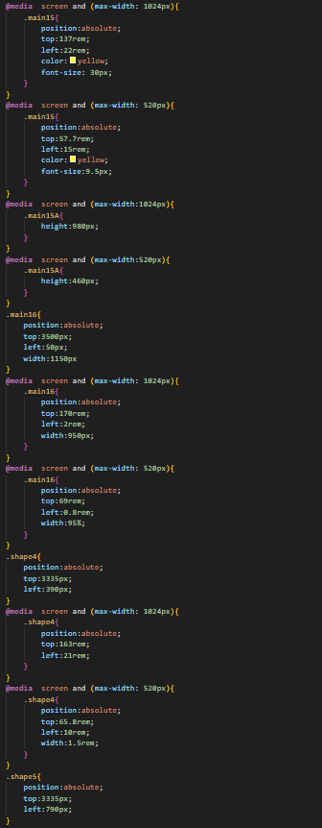

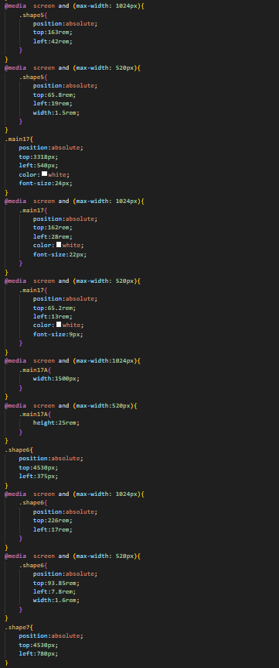

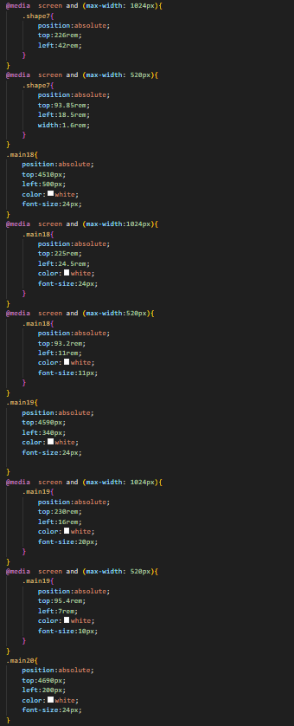

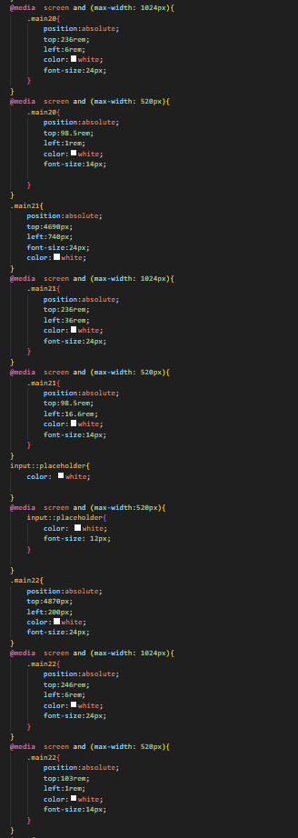

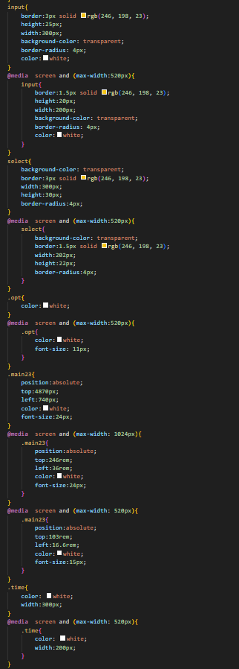

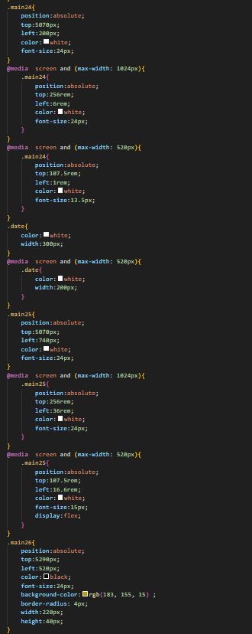

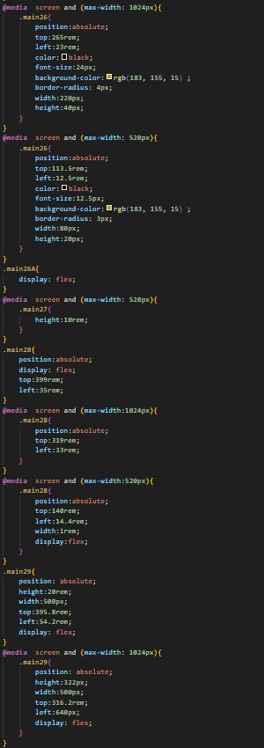

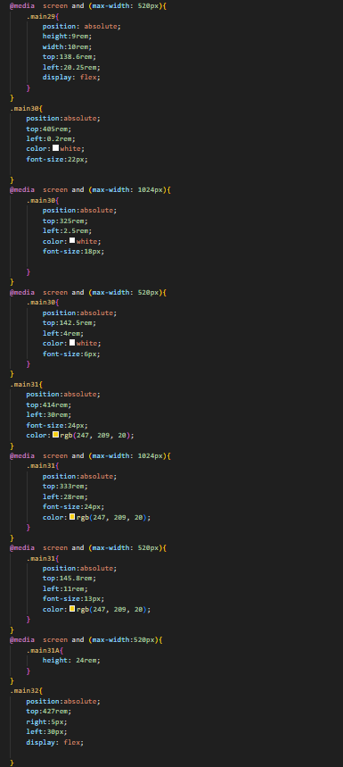

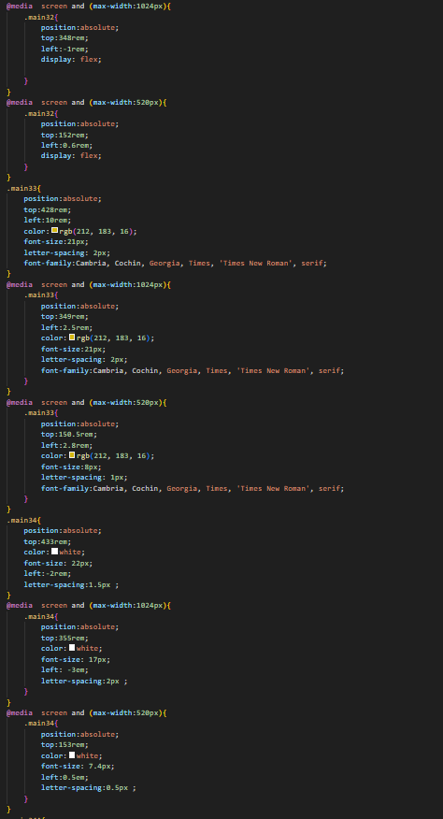

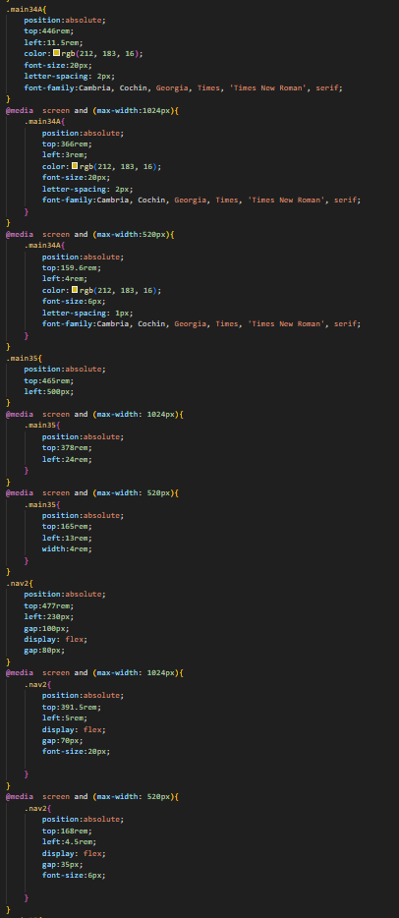

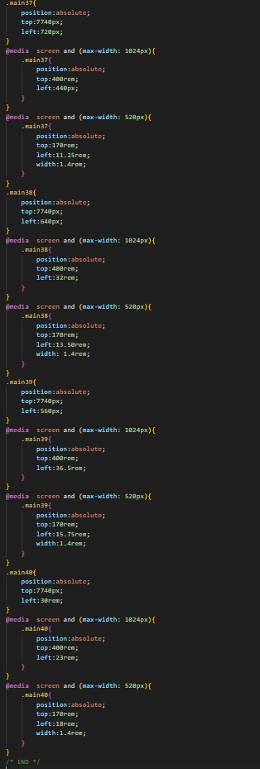

**References :-**

[www.photopea.com](http://www.photopea.com)

[www.w3schools.com](http://www.w3schools.com)

[Browse Fonts - Google Fonts](https://fonts.google.com/)